**Reischling Press, Inc.**

Reischling Press, Inc. (“RPI” or the “Company”) is a key print manufacturer and fulfillment partner for a leading group of B2C participants in the rapidly growing personalized consumer photo publishing market. The Company designs and delivers a broad range of personalized print-on-demand photo products and services, including photo books, other self-published books, photo greeting cards, invitations, stationery, posters, calendars, and similar items. RPI’s products are highly customized, manufactured on demand in small quantities, and delivered cost effectively to end consumers or retail stores within very short lead times.

The Company, based in Tukwila, Washington (south of Seattle), was founded in 1978 as a commercial printing company. In 1999, the company shifted its strategic focus to emphasize consumer markets. In 2007, RPI sold its commercial printing business to focus solely on consumer markets, specifically the personalized print-on-demand photo publishing sector. Today, RPI is a leading provider of design and manufacturing services to the consumer photo products and self-publishing sectors, serving major B2C customers that account for approximately including Blurb, Costco, FujiColor, Sam’s Club, TinyPrints, Walgreen’s, and Wal Mart.

RPI operates in two leased facilities totaling approximately 75,000 square feet. Its production capabilities are supported by state-of-the-art digital printing technology and Indigo presses manufactured by HP. The Company has about 40 full-time salaried “office” employees and approximately 60 full-time hourly production workers. During the peak holiday season, the production workforce is expanded utilizing a local temporary employment agency.

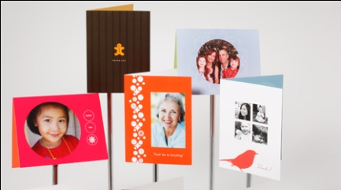RPI has developed important proprietary technology, particularly in its production system software, that enables it to maintain a high degree of seamless integration with its customers and achieve very rapid turnaround times for its orders. The Company’s patented “PrintFlo” software links directly with retail partners’ systems, enabling it to instantly receive orders submitted by end consumers through RPI’s partners’ portals. Once received, the orders are broken down by PrintFlo and efficiently loaded into RPI’s production system. PrintFlo has the capability to intelligently assess individual orders in the context of all orders and total available machine capacity, and optimally allocate jobs to the proper equipment and production lines within the factory at any given time.

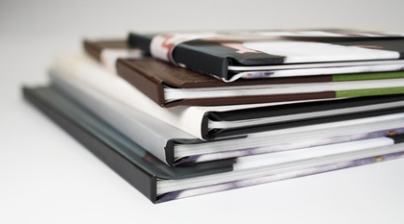Combined with other elements of RPI’s flexible, lean manufacturing system, PrintFlo enables RPI to balance its production and match its rate of output to actual demand, resulting in relatively efficient capacity utilization and high productivity for such a high mix, low volume order environment. Most of RPI’s orders consist of less than 25 pieces and are turned around in 1-2 days. RPI’s PrintFlo technology, combined with its focus on the personalized printed products market, provides the basis for a meaningful and sustainable competitive advantage.

[www.rpiprint.com](http://www.rpiprint.com)